

**Creating a TRAIN Account for Users Outside South Dakota Department of Health**

* Go to the

SD TRAIN PORTAL

Web Address:

train.org/sd/home

* Choose

“Create an Account”

CREATE ACCOUNT

1

START

* Please use your WORK email for your login name
* Set Time Zone and Zip Code for your **working** location
* Check “I agree to all TRAIN policies”
* Choose “Next Step”

ENTER ACCOUNT INFORMATION

2

● Choose the county in which you **reside**

* Click green ‘Confirm these selections’

SELECT COUNTY

3

* Organization: SD Department of Health **partner** you work for
* Title: Job Title
* Department: **Name of Health Clinic**
* Please use **work** address and phone number
* Choose **“**Next**”**

SELECT DOH EMPLOYEE STATUS

* Choose “Non-Department of Health Employee”

4

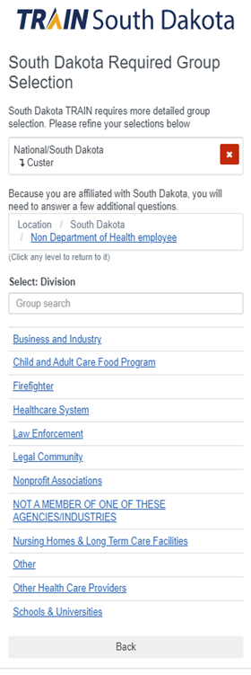

* Select **Healthcare Systems**

SELECT DOH PARTNER TYPE

5

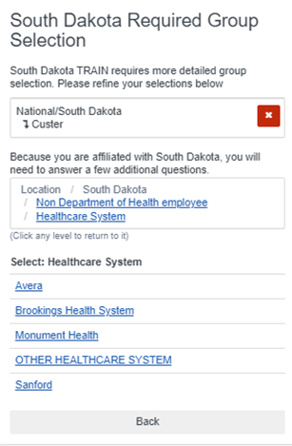

* Select the specific group you work for
* Some Healthcare Systems will have an office location to select on the next screen
* Select green “Confirm these selections” button
* Select blue “Continue” button

7

* Choose up to **THREE** roles which best fit your job functions
* Click the **circle** on the right of your primary role
* Click the blue “Continue” button that appears

SELECT PROFESSIONAL JOB ROLES

6

SELECT OFFICE

Heathcare System

SELECT WORK SETTING

* Choose up to **THREE** settings which best fit your job functions
* Click the **circle** on the right of your primary setting for work
* Click the blue “Finish Creating Account” button that appears

8